Mitla Taquito Order Form – Taquito Day: Friday, April 16, 2021
Order & Money due by Thursday, April 15, 2021
Beef Taquitos, beans & rice = $5.00
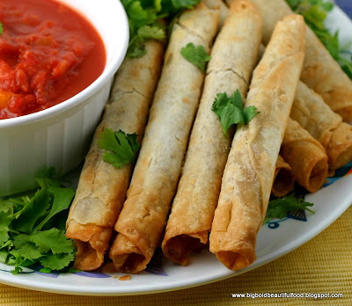
Please Print Name(s), Grade(s), and number of taquito orders at $5.00/order:

Mitla Taquito Order Form – Taquito Day: Friday, April 16, 2021
Order & Money due by Thursday, April 15, 2021
Beef Taquitos, beans & rice = $5.00
Please Print Name(s), Grade(s), and number of taquito orders at $5.00/order:

